WWW.VUTUBE.EDU.PK
FINALTERM EXAMINATION
Spring 2009
MTH101- Calculus And Analytical Geometry (Session - 1)
Question No: 1 ( Marks: 1 ) - Please choose one
If f is a twice differentiable function at a stationary point 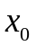 and 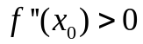 then f has relative …………. At

► Minima
► Maxima
► None of these

Question No: 2 ( Marks: 1 ) - Please choose one
If f is a twice differentiable function at a stationary point and 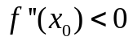 then f has relative …………. At

► Minima
► Maxima
► None of these

Question No: 3 ( Marks: 1 ) - Please choose one
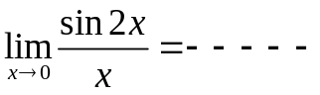

► 2
► 4
► 1
►

Question No: 4 ( Marks: 1 ) - Please choose one
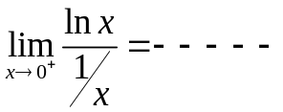

► 1
► 0
► e
► None of these

Question No: 5 ( Marks: 1 ) - Please choose one
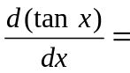
►
► 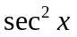
►
► 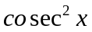

Question No: 6 ( Marks: 1 ) - Please choose one
If 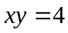 then 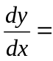
► 0
► 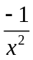
► 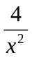
► 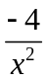

Question No: 7 ( Marks: 1 ) - Please choose one
Consider a function 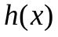and a constant then
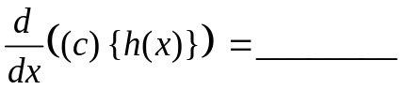

► 0
► 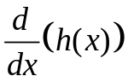
► 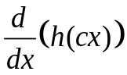
► 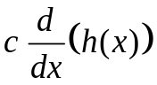

Question No: 8 ( Marks: 1 ) - Please choose one
Suppose that and are differentiable functions of then
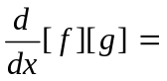

► 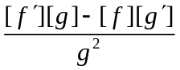
► 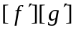
► 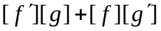
► 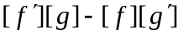

Question No: 9 ( Marks: 1 ) - Please choose one
The power rule, 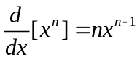 holds if n is __________
► An integer
► A rational number
► An irrational number
► All of the above

Question No: 10 ( Marks: 1 ) - Please choose one
Let a function be defined on an interval, and let  and 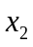 denotes two distinct points in that interval. If 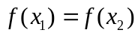 for all points and then which of the following statement is correct?
► is a decreasing function
► is an increasing function
► is a constant function

Question No: 11 ( Marks: 1 ) - Please choose one
If 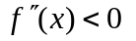on an open interval (a,b) then which of the following statement is correct?
► is concave up on (a, b).
► is concave down on (a, b)
► is linear on (a, b).

Question No: 12 ( Marks: 1 ) - Please choose one
What does 'n' represent in Riemann Sum 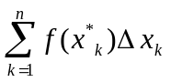?
► No. of Circles
► No. of Rectangles
► No. of Loops
► No. of Squares

Question No: 13 ( Marks: 1 ) - Please choose one
If  is continuous function such that 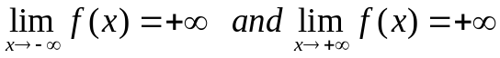 then has _________ on 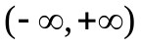
► maximum value but no minimum
► minimum value but no maximum
► both maximum and minimum value

Question No: 14 ( Marks: 1 ) - Please choose one
The expression 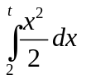, represents a function of :

►
►
►
► Both and

Question No: 15 ( Marks: 1 ) - Please choose one
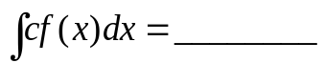

if c is a constant

► 0
►
► 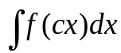
► 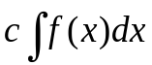

Question No: 16 ( Marks: 1 ) - Please choose one
Sigma notation is represented by which of the following Greek letter?

► 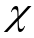
►
► 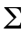
► 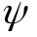

Question No: 17 ( Marks: 1 ) - Please choose one
In the following figure, the area enclosed is bounded below by :
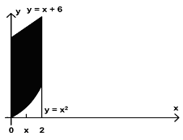
► 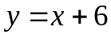
► 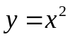
► 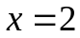
► 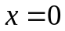

Question No: 18 ( Marks: 1 ) - Please choose one
In the following figure, the area bounded on the sides by the lines are :
►
►
► 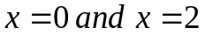
► 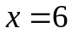

Question No: 19 ( Marks: 1 ) - Please choose one
What is the area of the region in the following figure?
► 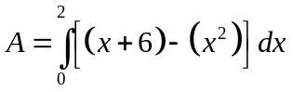
► 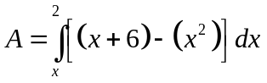
► 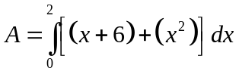
► 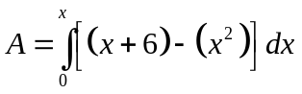

Question No: 20 ( Marks: 1 ) - Please choose one
Which of the following is approximate area under the curve 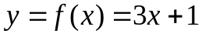 over the interval 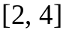, evaluated by using the formula

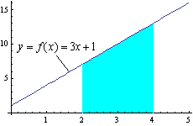
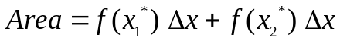

If the interval is divided into two sub-intervals of equal
length and 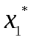 and 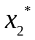 are left endpoint of each sub-interval.
► 17
► 20
► 23

Question No: 21 ( Marks: 1 ) - Please choose one
Which of the following is approximate area under the curve 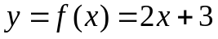 over the interval 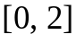, evaluated by using the formula

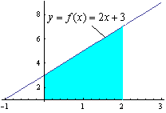

If the interval is divided into two sub-intervals of equal
length and and are right endpoint of each sub-interval.
► 8
► 10
► 12

Question No: 22 ( Marks: 1 ) - Please choose one
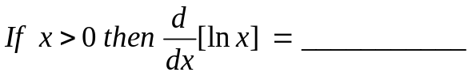
► 1
►
► 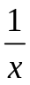
► 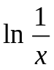

Question No: 23 ( Marks: 1 ) - Please choose one
Suppose and are integrable functions on [a,b] and c is a constant, then 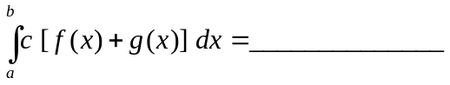
► 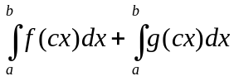
► 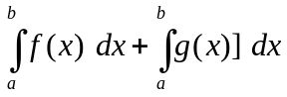
► 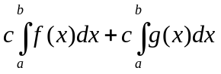
► 0

Question No: 24 ( Marks: 1 ) - Please choose one
If the function is continuous on [a,b] and if 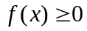 for all in [a,b], then which of the following gives area under the curve 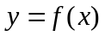 over the interval [a,b]?
► 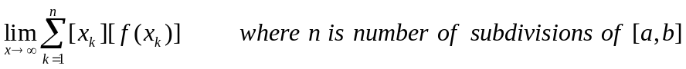
► 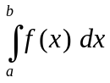
► 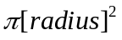
► (Width) (Height)

Question No: 25 ( Marks: 1 ) - Please choose one
Let region R in the first quadrant enclosed between 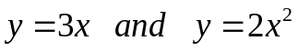 is revolved about the
x-axis .Which of the following equation gives the volume of a solid by cylindrical shells?
► 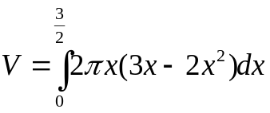
► 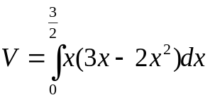
► 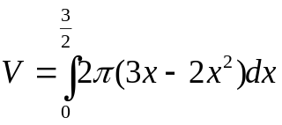
► 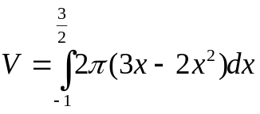

Question No: 26 ( Marks: 1 ) - Please choose one
Let f is a smooth function on [a, b]. What will be the arc length L of the curve y = f(x) from x = a to x = b?

► 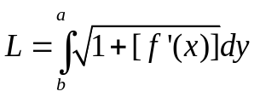
► 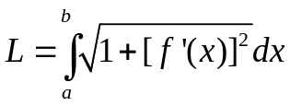
► 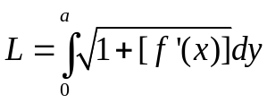
► 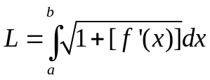

Question No: 27 ( Marks: 1 ) - Please choose one
If f is continuous on (a, b] but does not have a limit from the right then the integral defined by 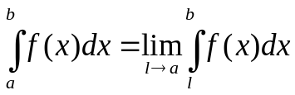 is called :

► Improper
► Proper
► Line

Question No: 28 ( Marks: 1 ) - Please choose one
For a sequence 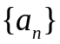 if the ratio of successive terms 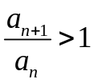then the sequence is known as:

► Increasing
► Decreasing
► Nondecreasing
► Nonincreasing

Question No: 29 ( Marks: 1 ) - Please choose one
For a sequence if the ratio of successive terms 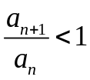then the sequence is known as:

► Increasing
► Decreasing
► Nondecreasing
► Nonincreasing

Question No: 30 ( Marks: 1 ) - Please choose one
Consider the indefinite integral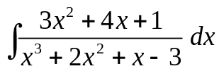
Let 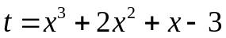

Is the following substitution correct?
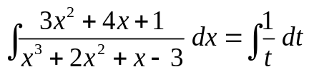
► Yes
► No

Question No: 31 ( Marks: 1 ) - Please choose one
The series 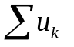 be a series with positive terms and suppose that 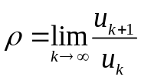 if 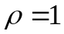 , then which of the following is true?

► Converges
► Diverges
► May converges or diverges
► Gives no information

Question No: 32 ( Marks: 1 ) - Please choose one
The series be a series with positive terms and suppose that 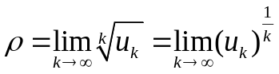 if , then which of the following is true?

► Converges
► Diverges
► May converges or diverges
► Gives no information

Question No: 33 ( Marks: 1 ) - Please choose one
If the series 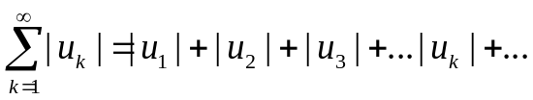 converges , then which of the following is true for 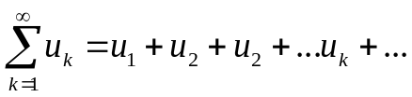?

► Converges
► Diverges
► Gives no information

Question No: 34 ( Marks: 1 ) - Please choose one
Let 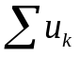 be a series with nonzero terms and suppose that 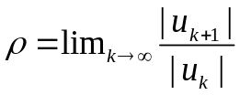 if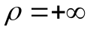, then which of the following is true?

► Then the series diverges
► The series converges absolutely and therefore converges
► May converges or diverges
► Gives no information

Question No: 35 ( Marks: 1 ) - Please choose one
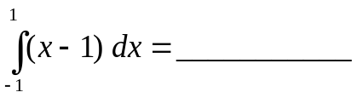
► -2
► 0
► 2
► 4

Question No: 36 ( Marks: 1 ) - Please choose one
How many critical points exist for a function 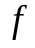 if
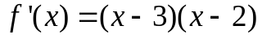
► Zero
► One
► Two
► Four

Question No: 37 ( Marks: 1 ) - Please choose one
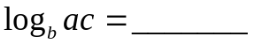
► 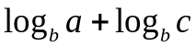
► 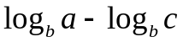
► 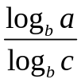
► 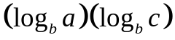

Question No: 38 ( Marks: 1 ) - Please choose one
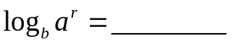

► 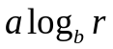
► 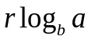
► 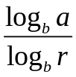
► 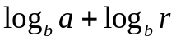

Question No: 39 ( Marks: 1 ) - Please choose one
Let 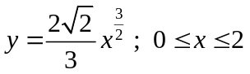 then which of the following is the length of the curve?
► 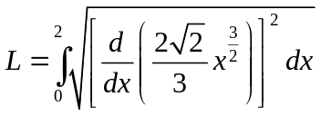
► 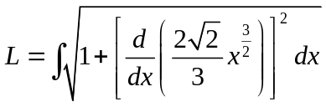
► 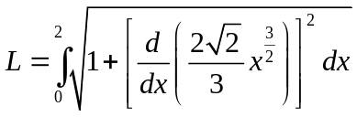
► 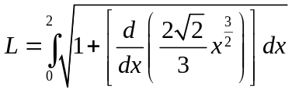

Question No: 40 ( Marks: 1 ) - Please choose one
Which of the following are first two terms for the Taylor series of 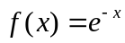 at x = 0?
► 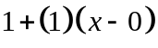
► 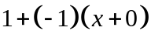
► 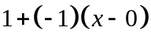
► 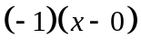

Question No: 41 ( Marks: 2 )
Evaluate the integral 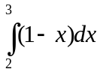

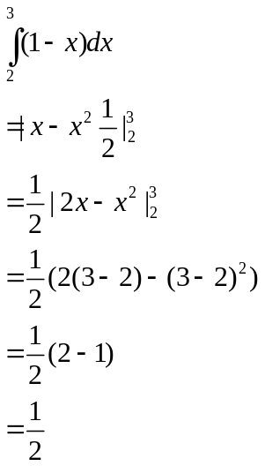
Question No: 42 ( Marks: 2 )
Evaluate the improper integral 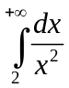

Question No: 43 ( Marks: 2 )
A function 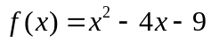 has critical point 2 in an interval [0, 5]. Find the maximum value of the function and point having this value.

Question No: 44 ( Marks: 3 )
Evaluate: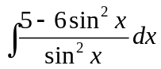
Question No: 45 ( Marks: 3 )
Find the area of the region bounded by the curve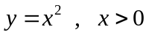, and bounded on the sides by the lines and 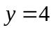

So we have
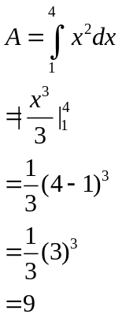

Question No: 46 ( Marks: 3 )
Determine whether the following sequence converges or diverges. If it converges, find the limit.
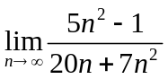

Question No: 47 ( Marks: 5 )
Use the Alternating series Test to determine whether the given series converges

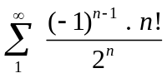

Question No: 48 ( Marks: 5 )
Evaluate the integral

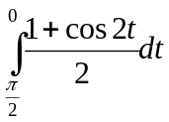
Solution

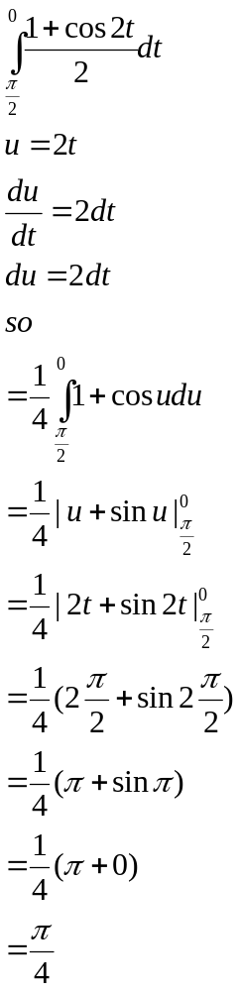

Question No: 49 ( Marks: 5 )
Evaluate the sums

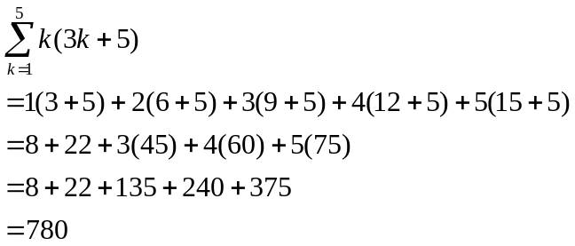

Question No: 50 ( Marks: 10 )
Find the volume of the solid that results when the region enclosed by the given curves is revolved about the x – axis.
